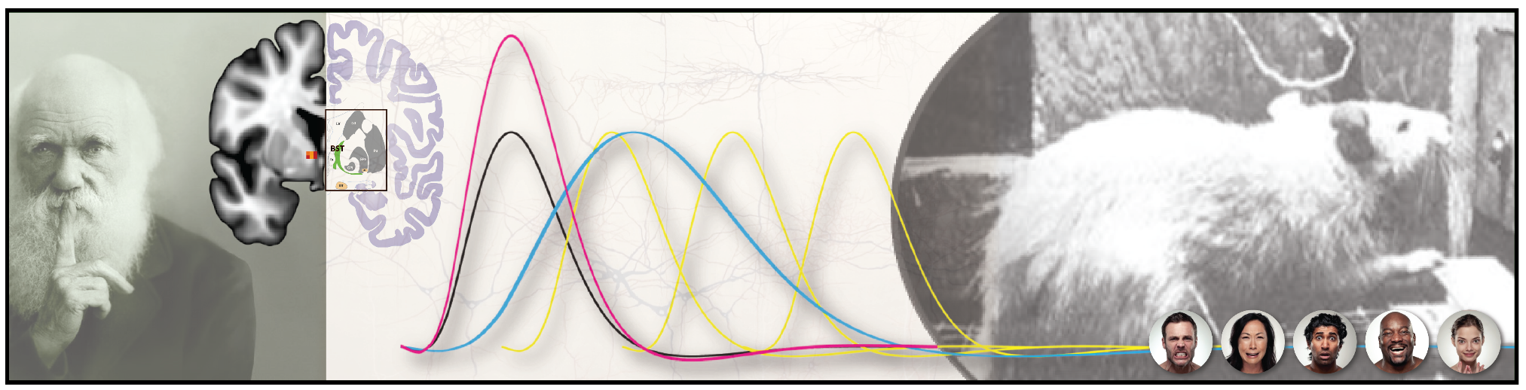

**PSYCHOLOGY/NACS 614**

**Emotion:**

***From Biological Foundations to Contemporary Debates in the Psychological Sciences***

***\*\*\* COVID-19 EDITION \*\*\****

**professor alex shackman, uNIVERSITY OF MARYLAND*,* fall 2020**

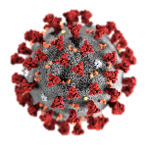Emotions play a crucial role in human experience: from the feelings of terror and rage that occasionally punctuate your morning Beltway commute, to the joy of seeing your newborn child for the first time. Movies like *“Inside Out”* and TV shows like *“Lie to Me”* attest to our collective fascination with emotion, and there is a keen interest among scientists, philosophers, and clinicians in understanding their nature and discovering their underlying mechanisms. Although recent years have seen tremendous advances in our understanding of the biological underpinnings of emotion, it has become increasingly clear that the field of *Affective & Translational Neuroscience*—my field!—is at an intellectual cross-roads, with leading scientists vigorously challenging the canon of theories, facts, and shared assumptions that has inspired and guided emotion researchers since the 1980s.

***Welcome to Psychology 614!*** In this multidisciplinary graduate seminar, we will explore the current state of our scientific understanding of emotional states and traits, their roots in the brain and genome, and their relevance to psychiatric disease. We will cover foundational knowledge in neuroscience and genetics, strengths and weaknesses of widely used methods, classic and cutting-edge empirical work, and ongoing conceptual debates. We will discuss crucial discrepancies between the ways that scientists and lay people conceptualize emotions. In addition to human neuroimaging and genomic-association studies, we will also explore biological research that affords causal insights, including animal models, acute pharmacological challenges, neurofeedback and brain stimulation approaches, and case studies of patients with circumscribed neural insults.

Emotional states, traits, and disorders reflect bidirectional interactions between the brain and psychosocial experience. Understanding the emotional brain requires a deep understanding of behavior, ethology, and emotion theory. Conversely, neurobiology has provided unique insights into the nature of the emotional mind—insights that cannot be obtained using ratings or other behavioral measures. In short, the psychology and biology of emotion are interdependent, and we cannot make much progress in one without the other. Accordingly, in this seminar we will delve deeply into both areas and explore their relevance to anxiety disorders, depression, addiction, and everyday temptation.

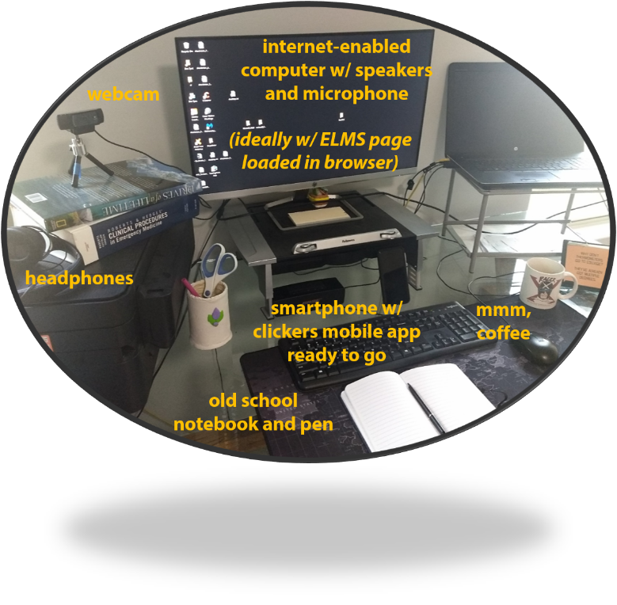**nuts and bolts[1]**

Because of the global COVID-19 pandemic, Psychology 614 is offered as a *synchronous* online course. It requires access to an internet-enabled computer equipped with a webcam, microphone, and speakers. If you lack consistent access to the necessary equipment or are uncomfortable participating in online classroom interactions, you should not enroll in this course.

We will meet on Mondays, from 9:00 AM to 11:45 AM, using Zoom in ELMS[2]

**Instructor:** Dr.Alex Shackman ([shackman@umd.edu](mailto:shackman@umd.edu)). Available by appointment.

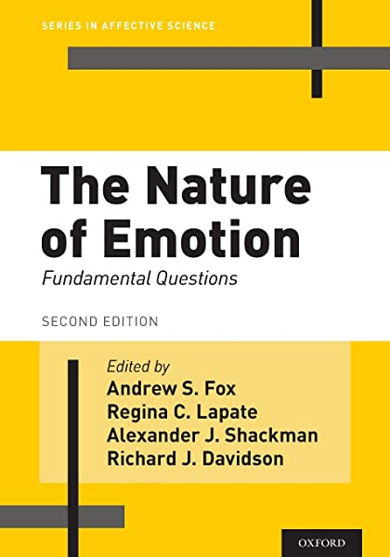**Required Materials**

* **Textbook**: *The Nature of Emotion* (2nd edition; Fox, Lapate, Shackman & Davidson Oxford University Press 2018)
  + Paperback and e-edition (~$45) at Amazon (<https://tinyurl.com/NoEAmazon>). FREE shipping.
* **Tech**: FREE ‘clickers’ application for your computer or mobile device[3]
* **Other Readings**
  + FREEin ELMS under the “Pages” tab (“Readings” subdirectory)
  + An overview can be found at <https://tinyurl.com/Psy614Fall2020ReadingListv1>
* **Announcements:** Shared via ELMS

***Continued…***

**LEARNING OBJECTIVES**[4]

Through exposure to classic and cutting-edge work drawn from the primary and secondary literatures, students will cultivate 4 kinds of expertise:

***✓ Affect.*** Foundational and graduate-level understanding of emotion

***✓ Biology.*** Foundational and graduate-level understanding of the brain and genome

***✓ Affective & Translational Neuroscience.*** Advanced integrative knowledge at the intersection of Affect and Biology. You’lldevelop the ability to synthesize

these two areas of scholarship, and understand how the mind, brain, and genome collectively give rise to emotional

experience, behavior, and disorders.

***✓ Critical Thinking.*** A healthy dose of skepticism is a core aspect of the scientific enterprise. We will explore on-going conceptual debates and discuss the

limitations of widely used approaches. This will enable you to strengthen your critical thinking skills; form your own scientific perspective

on the nature, biological bases, and implications of emotion for psychopathology; and become a more sophisticated producer, consumer,

or reviewer of affective neuroscience research

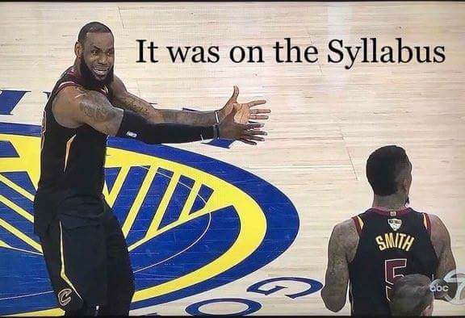The Assignments and Required Readings will help you develop expertise in each of these areas, reinforce the material covered in our classroom meetings, and strengthen your written science communications skills.

The Examinations will assess your competency in Affect, Biology, and Affective & Translational Neuroscience. They will help me to determine whether you understand the key factual points and arguments, and whether you can integrate the material and apply it to a broader context.

***Continued…***

A unique “textbook”—*the nature of emotion 2.0*

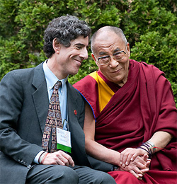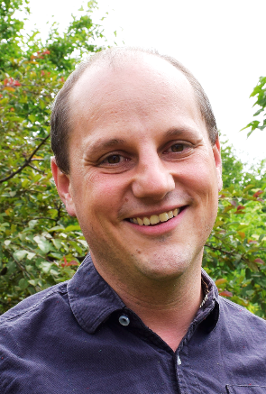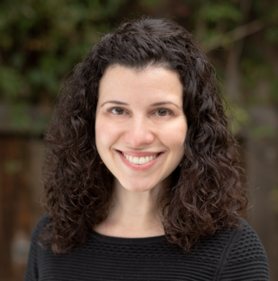

A couple of years ago, my friends and I edited a book, *The Nature of Emotion 2.0* (NoE). All of us are professors at research-oriented public universities (Drew Fox, UC-Davis; Regina Lapate, UCSB; Alex Shackman, UMD; Richie Davidson, UW-Madison), and one of our motivations for organizing and writing the book was to create an accessible, unified framework for teaching emotion and affective neuroscience.

To do so, we invited more than 100 leading emotion researchers from around the world—junior and senior, male and female—to address 14 fundamental questions about the nature and biological bases of emotion. For example: *What is an emotion? How are emotions organized in the brain?* At the end of each chapter, we wrote an Afterword, doing our best to integrate the various “expert responses” and highlight key areas of agreement and disagreement.

*So, the NoE is not your run-of-the-mill textbook or even a conventional scientific handbook.* There is not a singular, highly distilled viewpoint; there is no “Textbook Authority” voice. The NoE is a chorus of voices. Sometimes, they sing in harmony and sometimes it’s a decided cacophony. In both cases, the NoE seeks to highlight the most important lessons and challenges in the words of the leading researchers working in the field of affective (neuro-)science today.

*The NoE is our gift to you, our students and the next generation of emotion researchers.*

***Continued…***

**WHAT I WANT FOR YOU …**

* ***Be Engaged*** – Complete the required Reading Assignment—*all of it*—before class. Come to class meetings. Be a hunter of information: seek out what is interesting and useful to you.
* ***Be Skeptical.*** Read what is assigned and critically consider the claims. Decide for yourself whether you think it’s true, and what it means for theory or practice. *Just because something is published, doesn’t mean it’s right. Even if the approach is solid, the claims are often overblown!*
* ***Be Heard.*** Speak up in class and share your ideas—*even in moments where it feels scary or pointless*. Be prepared to ask questions and participate in discussions. There are many opportunities for us to learn from one another. Learning can stem from sharing knowledge or from asking questions. More often than not, many of your peers will be struggling with the same question. Help them by asking.
* ***Enjoy!*** *Have a positive experience!* Let us know early and directly if you are encountering any trouble or barriers. *We’re excited to have you aboard and want you to get the most out of this opportunity to learn more about the science of individual differences!*



**CLASS ETIQUETTE AND RULES**

* Take notes the old fashioned way, with pen or pencil in a notebook
* Ask questions about anything that you don't understand
* Be polite. Be punctual. *Timeliness is a critical professional skill. We have so much interesting material to cover and preciously little time together*
* Be present. Physically and mentally. You paid for the course—*get the most out of it!*
* Have realistic expectations about the amount of work involved. Completing the coursework and mastering the content takes time. University guidelines suggest that you should expect to spend ~2-3 hours outside of class for every hour spent in Zoom class meetings.
* I will post lectures after class. Slides and film clips can be found on ELMS under the “Files” tab (“Powerpoints” subdirectory).

***Continued…***

course structure

**1. Zoom Meetings**

Each meeting is organized around two 75-minute modules, with a break in the middle.

There are 2 kinds of meetings: ***Lecture*** and ***Discussion-Intensive***.

***Lecture-Based Meetings*** include 3 core components:

* A conceptual roadmap outlining the new topics and fundamental questions to be explored
* The science of emotion and the brain drawn from your readings and other sources. *There will be plenty of time for questions, discussion, and other kinds of active learning.*
* A recap of the most important take-home points

***Discussion-Intensive Meetings*** include 2 core components:

* A 30-45-minute roundtable discussion of the fundamental question discussed in the target NoE reading(s) (e.g. *What is an Emotion?*). Student Kick-Starter teams will lead and facilitate the discussion (see below for details).
* In the remaining time, Dr. Shackman will provide a short closing lecture (15-30 minutes). The closing lecture will provide a more formal summary of the essential background material, illustrative examples, and key take-home points.

**2. Required Reading[5]**

Readings for this course have been hand-picked by the instructor. The readings include recent and classic empirical reports, mini-reviews, and commentaries—w*hat better way to learn about emotion than straight from the most exciting researchers working in the field today?*

To get the most out of this course, it is crucial that you understand the key take-home points from the assigned readings

* **Focus on the larger take-home points and implications, *not* the technical aspects of the methods**
* **Ask questions about anything you found confusing or challenging. Feel free to email me.**

# ASSESSMENTS, ASSIGNMENTS, and grading

Your overall grade will be determined by 5 equally weighted (20%) components: multiple-choice exams, reaction papers, no-stakes clicker probes, flex papers, and a discussion kick-starter.

* The components are equally weighted because they are equally important.
* 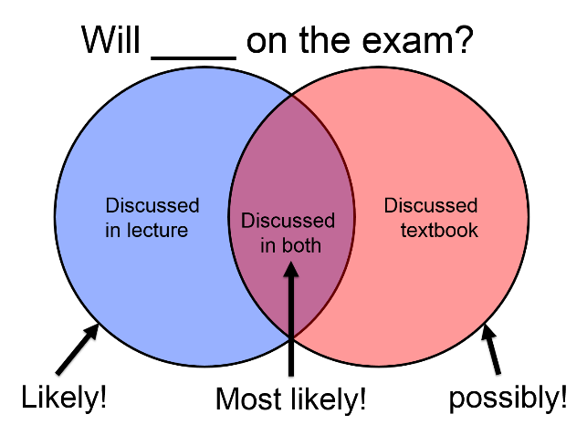In addition, you must earn a B- or better (≥80.0%) on each of the 3 exams in order to earn a B- or better in the course. In the unlikely event that your overall grade is B- or better (≥80.0%) at the end of the term, but you earn a C+ or lower (<80.0%) on one or more exams, then your overall grade will be curved down to a C+. This criterion was designed to ensure that all students who earn an A or a B have demonstrated competency in Affect, Biology, and Affective Neuroscience.

### 1. Three Open-Note Multiple-Choice Exams (Total: 3 x 13.33% = 40%)

The 3 non-cumulative, open-note, multiple-choice exams will assess competency in Affect, Biology, and Affective Neuroscience, respectively1.

* Exams will be administered using the Quizzes feature of ELMS, and will occur during the regularly scheduled meeting time
* Multiple-choice questions that involve critical thinking about concepts drawn from the lectures as well as the required reading—*everything in writing is fair game.*
* Much of the exam material is not contained verbatim in the lecture slides, *so attendance and engagement will be crucial to your success*
* Make-up exams will only be considered in exceptional circumstances and may involve different questions than the usual exam

### 2. Weekly Reaction Papers (Total: 20%; 2 lowest grades dropped)

Most weeks, you will be required to submit a brief written *Reaction* to one or more of the assigned readings ***for each module***

* The goal is to help you to organize your thoughts, consolidate and integrate the material, and refine your critique prior to the class meeting
* Detailed instructions: <https://tinyurl.com/ShackRPInstructions2020>
* Grading: 1 (full credit), 1⁄2 (half-credit), 0 (no credit).
* At the end of the semester, your 2 lowest grades will be dropped—*so there is no need to stress when the occasional unexpected issue crops up (e.g. illness, spaced out, etc.).*

### 3. In-Class Quizzes/Surveys Using Clickers (Total: 20%; 2 lowest grades dropped)

Many of the lectures include **no-stakes** surveys, quizzes, and learning checks conducted using Clickers.

* *So long as you participate, you will receive full credit!*
* If you occasionally encounter a technical issue, don’t sweat—the two lowest grades will be dropped.

**4. Discussion Kick-Starter (Total: 20%)**

* A total of 4 modules are designated ‘Discussion-Intensive.’
* Once a semester, you will work as a part of a small team to kick-start and facilitate a 30-45-minute roundtable discussion of the fundamental question discussed in the target reading(s) (e.g. *What is an Emotion?*).
* Detailed instructions: <https://tinyurl.com/ShackDKSInstructions2020>
* Grading is based on effort and participation: 1 (full credit), 1⁄2 (half-credit), 0 (no credit)
* Please reach out to me as soon as possible, if you need to switch your assigned module (see Timetable)
* Please be respectful of the student-discussants. *It’s tough to facilitate a discussion if your classmates haven’t read the target material, don’t show up, or never speak. Please come to every class prepared to engage, whether you’re a discussant or not*

***Continued…***

**TIPS FOR getting the most out of on-line learning**

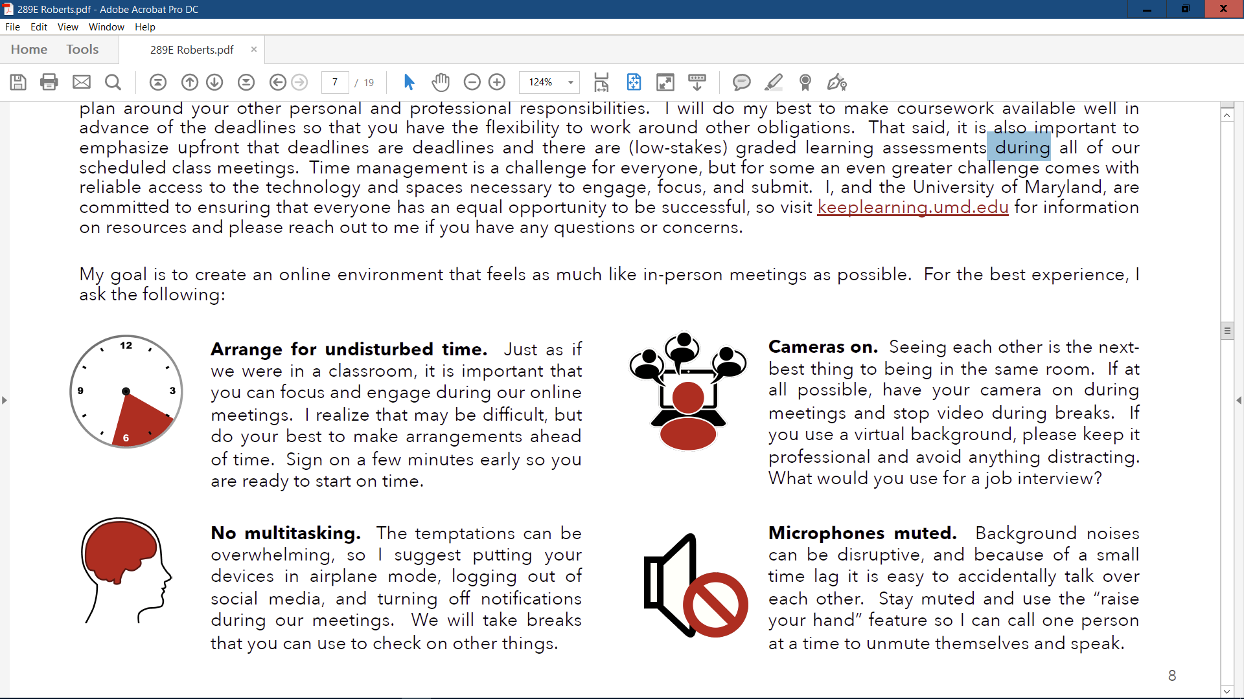

***Continued…***

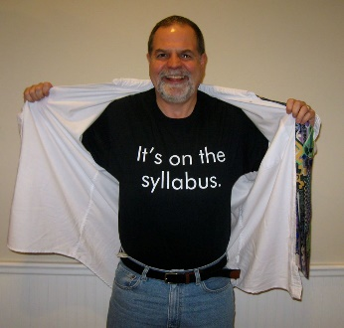**EVIDENCE-BASED TIPS FOR ACADEMIC succeSS**

* Review your notes EVERY DAY—even if you only have a couple of minutes
* Spread out study sessions to maximize learning and retention
* Study past lectures. Think about critical questions and topics
* Study the hard stuff first
* Organize your notes into meaningful clusters. *Linking new information to prior knowledge is crucial for learning*
* Make YOUR OWN study guide and practice tests
* Teach yourself by teaching someone else (*This is a great way to test or strengthen your understanding!*)
* Seek out help when you need it…*the earlier the better!*

***Continued…***

**Timetable**

|  |  |
| --- | --- |
| Date | Activities and Assignments |
| Mon 08/31 | Module 01. Introductions, Course Philosophy & Mechanics |
| Mon 09/07 | No Class / Labor Day |
| Mon 09/14 | No Class / Dr. S Away |
|  | |
| SECTION I: THE PSYCHOLOGICAL NATURE OF THE EMOTIONAL MIND | |
| Mon 09/21 | Module 02. What is an Emotion?  Discussants**: Alexandra, Emily, Genevieve, Jose, Kat**  RP for M02 Due at 9 AM |
| Mon 09/21 | Module 03. How Are Emotions Expressed and Perceived?  Discussants: **Joung Yon, Kirsten, Mary, Priya, Samantha W**  RP for M03 Due at 9 AM |
| Mon 09/28 | Module 04. How Are Emotions Regulated?  Discussants: **Rewina, Samantha H, Shereen, Svetha, Tolulope**  RP for M04 Due at 9 AM |
| Mon 09/28 | Module 05. Emotional Traits  RP for M05 Due at 9 AM |
| Fri 10/02 | **\*\*\* Flex Paper #1, Psychological Focus: *Draft Due to Dr. S* \*\*\*** |
| Mon 10/05 | Module 06. How are Emotional Traits and States Related? What Do Emotional Traits Do? (Part 1)  RP for M06 Due at 9 AM |
| Mon 10/05 | Module 07. How are Emotional Traits and States Related? What Do Emotional Traits Do? (Part 2)  RP for M07 Due at 9 AM |
| Fri 10/09 | **\*\*\* Flex Paper #1, Psychological Focus: *Peer Review Due to Dr. S* \*\*\*** |
| Mon 10/12 | Module 08. How are Emotional Traits and States Related? What Do Emotional Traits Do? (Part 3)  RP for M08 Due at 9 AM |
| Mon 10/12 | Module 09. The Interplay of Emotion and Cognition  RP for M09 Due at 9 AM |
|  | |
| SECTION II: NEGATIVE AFFECT | |
| Mon 10/19 | Module 10. Neuroticism/Negative Emotionality (N/NE)  RP for M10 Due at 9 AM |
| Mon 10/19 | Module 11. Childhood Behavioral Inhibition (BI)  RP for M11 Due at 9 AM |
| Mon 10/26 | **\*\*\* First Examination: *Focus on Affect* \*\*\*** |
| Mon 10/26 | **\*\*\* First Examination: *Focus on Affect* \*\*\*** |
| Fri 10/30 | **\*\*\* Flex Paper #1, Psychological Focus: *Revised Paper & Review Response Submission Deadline* \*\*\*** |
|  | |
| SECTION III: THE BRAIN | |
| Mon 11/02 | Module 12. The Brain: *Foundations in Neuroscience (Part 1)*  *No RP* |
| Mon 11/02 | Module 13. The Brain: *Foundations in Neuroscience (Part 2)*  *No RP* |
|  | |
| SECTION IV: GENETICS: *FOUNDATIONS AND APPLICATIONS TO EMOTION* | |
| Mon 11/09 | Module 14. Part 1: *Heritability and Behavioral Genetics*  RP for M14 Due at 9 AM |
| Mon 11/09 | Module 15. Part 2: *Molecular Genetics and GWAS*  RP for M15 Due at 9 AM |
| Mon 11/16 | Module 16. Part 3: *Neurogenetics and Epigenetics*  RP for M16 Due at 9 AM |
| Mon 11/16 | TBD/Flex |
| Mon 11/23 | **\*\*\* Second Examination: *Focus on Biology* \*\*\*** |
| Mon 11/23 | **\*\*\* Second Examination: *Focus on Biology* \*\*\*** |
|  |  |
|  | |
| SECTION V: THE EMOTIONAL BRAIN—*BASIC & CLINICAL AFFECTIVE NEUROSCIENCE* | |
| Mon 11/30 | Module 17. The Human Brain and Emotion: *Significance and* *Methodological Foundations*  *No RP* |
| Mon 11/30 | Module 18. The Neurobiology of Negative Affect: *Focus on the Amygdala*  RP for M18 Due at 9 AM |
| Fri 12/04 | **\*\*\* Flex Paper #2, Biological Focus: *Draft Due to Dr. S* \*\*\*** |
| Mon 12/07 | Module 19. The Neurobiology of Positive Affect and Reward (Part 1): *Wanting, Liking, and Depression*  RP for M19 Due at 9 AM |
| Mon 12/07 | Module 20. The Neurobiology of Positive Affect and Reward (Part 2): *Temptation, Craving, and Addiction*  RP for M20 Due at 9 AM |
| Fri 12/11 | **\*\*\* Flex Paper #2, Biological Focus: *Peer Review Due to Dr. S* \*\*\*** |
| Mon 12/14 | Module 21. The Brain and Emotion: *Key* *Conceptual Lessons and Future Challenges*  Discussants: **Alexander, Junaid, Kristen, Shannon, Zizhong/David**  RP for M21 Due at 9 AM |
| Mon 12/14 | Module 22: Semester Re-Cap |
| Fri 12/18 | **\*\*\* Flex Paper #2, Biological Focus: *Revised Paper & Review Response Submission Deadline* \*\*\*** |
| Sat 12/19 8-10 AM | **\*\*\* Third Examination: *Focus on Basic & Clinical Affective Neuroscience* \*\*\*** |

Please note: This schedule is subject to change. Any updates will be announced in class and posted on ELMS.

***Continued…***

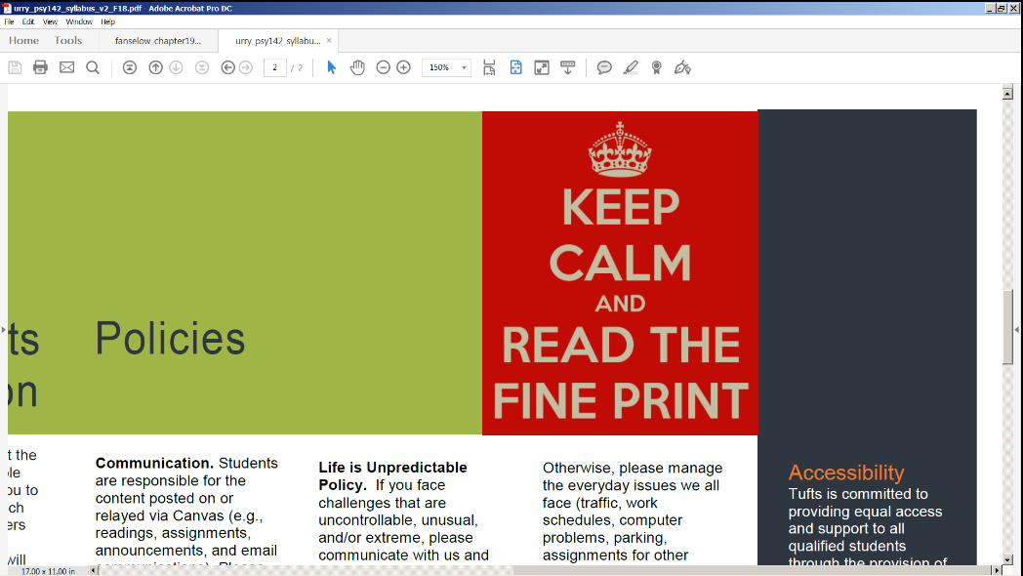**additional policies and resources**

I expect you to take personal responsibility for you own learning. This includes acknowledging when your performance does not match your goals and doing something about it. Everyone can benefit from some expert guidance on time management, note taking, and exam preparation, so I encourage you to visit <http://ter.ps/learn> or <https://tutoring.umd.edu> and schedule an appointment with an academic coach. Or, if you just need someone to talk to, I encourage you to visit <http://www.counseling.umd.edu>. *Remember, everything is free because you already paid for it and everyone needs help…all you have to do is ask for it.*

Students are responsible for knowing the relevant course and University policies

* <http://www.ugst.umd.edu/courserelatedpolicies.html>
* <https://tinyurl.com/ShackPolicies2018>
* ***Life is Unpredictable Policy***
  + If you face challenges that are uncontrollable, unusual, or extreme, please let Dr. Shackman know as soon as possible. If you’re ill, please send me a notification via email or ELMS. Otherwise, please manage the everyday issues that we all face (traffic, work schedules, computer problems, parking, assignments for other classes) so that you can meet succeed without special accommodations.
* ***Working Together to Cultivate a Respectful and Inclusive Learning Environment***
  + As an instructor, one of my central goals, is to create a safe, welcoming, and respectful environment for students of different genders, races, ethnicities, sexual orientations, socioeconomic groups, political parties, and religious and educational backgrounds. UMD is one of the nation’s most diverse campuses (<https://tinyurl.com/UMDDiversity2018>). Students of color comprise ~40% of all undergraduates. Many students are first-generation Americans or first-generation college students, and many transferred from smaller schools around the state (as did my own parents). Some of you hail from ‘liberal’ urban areas (like my father’s family), and others come from more conservative, traditional, or rural backgrounds (like my mother’s). I will treat all of you equally, without distinction, and do my best to foster an inclusive learning environment.
  + Please be courteous, sensitive, and respectful of others’ perspectives, even when they differ from your own, and do your best to argue charitably, on the basis of data, rather than conjecture, anecdotes, or rhetorical tricks
  + The course is designed to promote thoughtful conversation and active student engagement—inside and outside the classroom. Given the number of students and the preciously small amount of time that we have together, on occasion, I may need to redirect or pause the dialogue. Please don’t mistake the necessities of time management for a lack of respect or interest. I’m interested in what you have to say and what you think. Please take advantage of other opportunities for continuing our conversation outside the classroom, whether that be via email or on-line office hours.

***Continued…***

* ***Trigger Warning*** 
  + As a mental health researcher, I know that many of you have first-hand experience with adversity, trauma, and mental illness, and you should be aware that our classroom discussions will sometimes touch on potentially sensitive issues. *We discuss people. People have problems and people do bad things and have bad things happen to them. People get hurt, or hurt themselves. The odds are high that something I say in class or that a student says will bother someone.* This is particularly true when we discuss some of the misfortunes that have befallen Patient SM. If you have a concern, please be as proactive as possible and let me know in advance. I am more than happy to work with you to create the best possible learning environment.

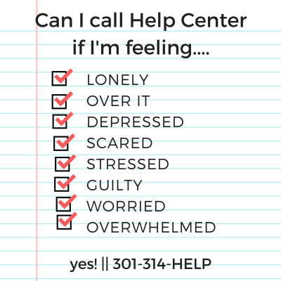

* ***Racism and Hatred.*** If you experience racism or hatred, we encourage you to let us know. You are also encouraged to report your experience to the Office of Diversity and Inclusion (<https://www.diversity.umd.edu/hbrp>).
* ***Student Hunger & Basic Needs***
  + If you or another student has difficulty affording groceries or getting enough to eat every day, or lacks a safe and stable place to live, please check out these campus resources
    - <http://www.crisisfund.umd.edu>
    - <http://campuspantry.umd.edu>
    - <https://umd.edu/fostering-terp-success>

***Continued…***

**ABOUT THE course**

Professor Alex Shackman

Dr. Shackman is an Associate Professor in the Department of Psychology (Clinical & CNS Area Groups), a core faulty member of the interdepartmental Neuroscience and Cognitive Science (NACS) Graduate Training Program and the Maryland Neuroimaging Center (MNC), and the Director of the Affective and Translational Neuroscience Laboratory at the University of Maryland. His work is supported by the NIMH and NIDA. Dr. Shackman is Co-Editor of *The Nature of Emotion* (Oxford University Press), serves as Associate/Consulting Editor at several journals, and has co-edited two special issues focused on the neurobiology of emotional states, traits, and disorders. Dr. Shackman is an active member of the Hierarchical Taxonomy of Psychopathology (HiTOP) consortium and frequently reviews grant applications for the NIH and NSF. To learn more about his work, please visit <http://shackmanlab.org>.

Acknowledgements

This course was developed from scratch by Dr. Shackman, but it owes a heavy debt of gratitude to many friends and colleagues: Dr. Ralph Adolphs (CalTech), Yoni Ashar (Boulder), Dr. Brad Bushman (OSU), Dr. Kristin Buss (Penn State), Dr. Kim Chiew (Denver), Dr. Ryan Curtis (Maryland), Dr. Andrew Fox (Davis), Dr. Hill Goldsmith (Wisconsin), Dr. Jamie Hanson (Pitt), Dr. Jens Herberholz (Maryland), Gloria Kim (Maryland), Dr. Kevin Labar (Duke), Dr. Kristen Lindquist (UNC Chapel Hill), Dr. Kateri McRae (Denver), Dr. Koraly Perez-Edgar (Penn State), Dr. Brent Roberts (UIUC), Dr. Scott Roberts (Maryland), Dr. Ken Rubin (Maryland), Dr. Amitai Shenhav (Brown), Dr. Rebecca Shiner (Colgate), Dr. Jason Smith (Maryland), Dr. Leah Somerville (Harvard), Dr. Heather Urry (Tufts), Dr. Tor Wager (Dartmouth), Dr. Dave Yager (Maryland), Dr. David Zald (Vanderbilt), and many of my prior students. *Your feedback has been invaluable for refining and strengthening the course!*

***Continued…***

**appendix—*AN INTERDEPENDENT LEARNING COMMUNITY***

My colleague (and teaching hero), Dr. Scott Roberts, describes the college learning environment as a ‘community of learners,’ where each of us has a defined set of roles, expectations, and responsibilities. I could not agree more!

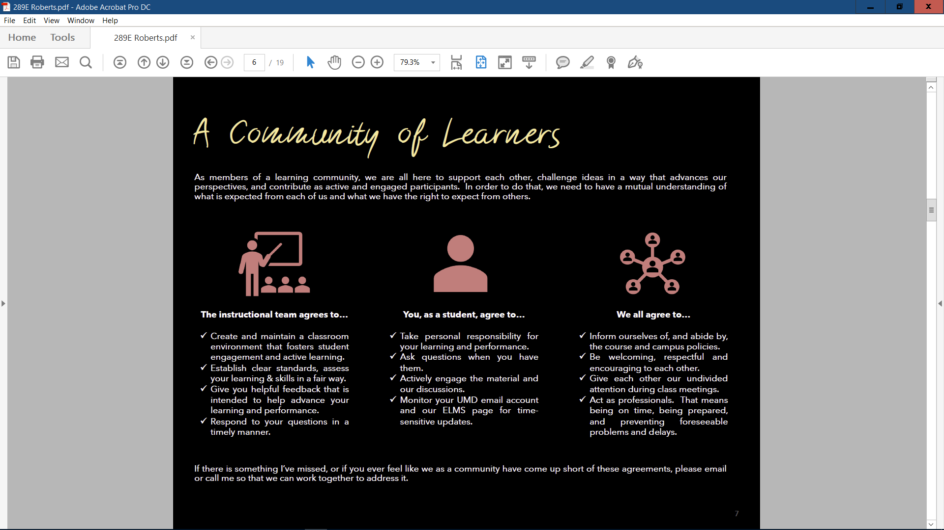

1. Academic Calendar: <http://www.provost.umd.edu/calendar/>
2. Detailed Zoom Instructions: <https://tinyurl.com/UMDStudentZoomInstructions>. Activate your Zoom UMD account and test it by visiting <https://umd.zoom.us>. ***The email in your ELMS profile must be identical to your email in your UMD zoom profile (e.g.*** [***echad@termail.umd.edu***](mailto:echad@termail.umd.edu) ***vs.*** [***echad@umd.edu***](mailto:echad@umd.edu) ***will prompt an error)***. See <https://tinyurl.com/ShackZoomInElmsFixEmails> to troubleshoot and fix. Please understand that we are not able to diagnose and fix technical difficulties with campus digital tools or your computing devices. If you encounter technical problems with course-related digital resources (e.g. ELMS, Clickers) please consult with the IT Helpdesk (<https://helpdesk.umd.edu>).
3. For instructions and assistance, please see <https://ugst.umd.edu/keeplearning/technology.html> and <https://go.umd.edu/tt-setup>.
4. This course is designed to fulfill the APA requirements for doctoral students in clinical psychology (<https://www.apa.org/ed/accreditation/section-c-soa.pdf>; C-7 D. Discipline-Specific Knowledge), including foundational and graduate-level knowledge in Affect (Category 2), Biological Bases of Behavior (Category 2), and their integration (Category 3).
5. <https://tinyurl.com/Psy614Fall2020ReadingListv1>